Problem Statement

Dream Homes NYC is a rapidly expanding real estate agency in the Tri-State area that connects home sellers with buyers and homeowners with renters across condos, townhouses, single-family homes, and rental units. As the agency grows, its spreadsheet-based workflows make it difficult to keep data consistent, track performance across teams, and generate reliable insights.

In this project, we act as an external consulting team tasked with modernizing their data infrastructure so leadership can make better decisions and eventually support a customer and agent web app.

Proposed Solutions
To address Dream Homes NYC’s fragmented, spreadsheet-based workflows, we proposed developing a centralized relational database management system (RDBMS) built on PostgreSQL. This solution would unify customer data, property inventory, listings, transactions, and corporate operations into a single, consistent source of truth. The system also integrates an analytics layer that can address the business requirements outlined by leadership across customer management, property trends, market analysis, and agent performance.

The proposed solution includes:
- A fully normalized database schema (3NF) covering Customer, Inventory, and Corporate Operations domains.
- Automated data generation, cleaning, and loading using Python, Faker, pandas, and SQLAlchemy.
- Analytical capabilities using SQL joins, aggregations, window functions, and transformations.
- Visualization dashboards in Metabase.

This approach ensures cleaner data governance, faster analytics, and a long-term foundation for Dream Homes NYC’s digital transformation.

Initial Action Plans
Because this was an academic project with no access to real operational data, we relied entirely on secondary research to design a realistic system. We studied platforms like Zillow and StreetEasy to understand the structure of real estate apps, including price histories, neighborhood insights, school ratings, walkability scores, and listing details. This is to ensure that our schema aligns with industry standards and supports a future integrated web application.

Using the business requirements that we brainstormed earlier in the project, we designed a fully normalized (3NF) relational schema organized into Customer, Inventory, and Corporate Operations domains. We built an ERD, then implemented the design in PostgreSQL. With no actual dataset available, we generated synthetic data through Python, Faker, pandas, and SQLAlchemy, then ran an ETL pipeline to clean, standardize, and load the data in dependency order.

Once populated, the database supported analytical SQL queries to address key requirements, including customer conversion, contract forecasting, neighborhood trends, pricing behavior, and agent performance. Finally, we created Metabase dashboards that present these insights in a clear, accessible format for both analysts and executives.

Goals and Target Achievements
The goal of this project was to modernize Dream Homes NYC’s data infrastructure and help the company transform into a data-driven real estate organization. Our objectives centered on building a reliable operational database to support analytics across customers, properties, agents, and market behavior. By moving away from fragmented spreadsheets and manual reporting, the company would benefit from improved data quality, streamlined workflows, and faster access to critical insights.

Team Contract and Responsibilities

To ensure smooth coordination and equal contribution throughout the project, our team created a contract outlining each member’s responsibilities across the major components of the work.

Business Requirements | Sarah Mastiur | Indang Safitrie
Business Requirements | Mohammed Islam | Ashley Choi
Database Design | Sarah Mastiur
PostgreSQL Queries Design: Database | Corporate Office | Mohammed Islam
PostgreSQL Queries Design: Database | Inventory | Indang Safitrie
PostgreSQL Queries Design: Database | Customers | Ashley Choi
ER Diagram Extraction | Sarah Mastiur | Indang Safitrie
Python Data Extraction | Corporate Office | Mohammed Islam
Python Data Extraction | Inventory | Indang Safitrie
Python Data Extraction | Customers | Ashley Choi
Python Data Integration | Indang Safitrie
PostgreSQL Queries Design: Business Requirements | Corporate Office | Mohammed Islam
PostgreSQL Queries Design: Business Requirements | Inventory | Indang Safitrie
PostgreSQL Queries Design: Business Requirements | Customers | Ashley Choi
PostgreSQL Queries Design: Business Requirements | Market & Pricing | Sarah Mastiur
Metabase | Sarah Mastiur

Database Design

Our database design was directly shaped by the business requirements provided for this project, which outlined the key questions Dream Homes NYC needs to answer across four major areas: customer management, property and inventory analysis, corporate operations, and market pricing trends.

These business requirements included:
- Customer Management Questions
  - How many appointments result in actual sales within 30/60/90 days?
  - How many active contracts are pending closing, and what is the average close timeline?
  - What does the customer profile look like across the current pipeline, including demographics such as age, family composition, and household income levels?
2. Property & Inventory Questions
  - How many properties are listed in each neighborhood, and what is the average price per square foot by neighborhood?
  - How many housing units are located within one ZIP code of a Grade A Public High School?
  - Which neighborhoods have the highest price appreciation year-over-year?
  - How many properties are in walkable neighborhoods (score 70+) vs. car-dependent areas (score <50)?
  - What percentage of sold properties had a price reduction before closing?
3. Corporate Operations Questions
  - What is the total commission earned by each agent this month, and how does it compare to their monthly target?
  - Which office location generated the most revenue in the past quarter?
  - What is the average commission split between brokers, agents, and teams across different transaction types?
  - Which agent team has the highest average sales price and lowest average days-on-market?
4. Market Analysis & Pricing Questions
  - What is the average price-per-square-foot trend for condos vs. townhouses vs. single-family homes in New York?
  - What is the price trend for 2-bedroom apartments over the past 12 months?
  - How many properties in a given neighborhood are within 10% of their asking price vs. sold below asking?
  - Which neighborhoods show the strongest demand for rentals compared to homes for sale, based on inquiry and occupancy rates?
  - What is the percentage of deals in the pipeline that successfully convert into completed transactions, and how does this conversion rate compare between rental and sales listings?
  - What is the average time on market for rental listings compared to for-sale listings?

Using these needs as our baseline, we identified the entities, relationships, and attributes necessary to support these analytical goals and structured our schema around three domains: Customers, Inventory, and Corporate Operations. We then created the full set of PostgreSQL DDL statements to implement this schema, ensuring that each table and constraint directly supported at least one of the targeted business questions.

Below is an example of the Neighborhoods table schema, designed to support business questions on walkability, price trends, and school proximity.

CREATE TABLE Neighborhoods (
neighborhood_id SERIAL PRIMARY KEY,
neighborhood_name VARCHAR(120) NOT NULL,
city VARCHAR(120) NOT NULL,
state VARCHAR(2) NOT NULL CHECK (state IN ('NY', 'NJ', 'CT')),
zip_code VARCHAR(10) NOT NULL,
walkability_score INTEGER CHECK (walkability_score BETWEEN 0 AND 100),
UNIQUE (neighborhood_name, city, state, zip_code)
);

After validating the schema, we extracted the ERD and refined it in Lucidchart, which helped confirm that all relationships aligned with the required analytical workflows. This design provided a clear, normalized foundation for building PostgreSQL queries to address the business requirements.

Sample Dataset and Rationale

To populate our database, we created 14 separate synthetic datasets, one for each table in our schema. This approach made the extraction process more manageable and ensured each dataset could be validated independently before loading into PostgreSQL. Because this is an academic project with no access to real operational data, synthetic generation allowed us to simulate realistic records while maintaining full control over data quality, relationships, and constraints.

We used Python, Faker, pandas, and SQLAlchemy to generate these datasets. Each table was built with its own script, and foreign keys were handled carefully. We inserted parent tables first, let PostgreSQL assign primary keys through its SERIAL mechanism, then retrieved those IDs to populate dependent tables. This ensured referential integrity and enabled us to test the schema accurately.

Below is an example of how the Offices and Teams datasets were generated. Offices were created first, inserted into the database, and then queried to retrieve their IDs, which were reused as foreign keys in the Teams dataset. This method was repeated across all tables to maintain clean and consistent relationships.

# OFFICES (5–8 rows)

offices = []
for _ in range(random.randint(5, 8)):
state = random.choice(['NY','NJ','CT'])
offices.append({
# office name is generated using the city name to help keep names unique
"office_name": f"Dream Homes {fake.city()} Office",
"address": fake.street_address(),
"city": fake.city(),
# state is selected randomly for simple geographic variety
"state": state,
"zip_code": fake.zipcode(),
# phone trimmed to 20 chars to fit schema limit
"phone": re.sub(r"[^0-9+()-]", "", fake.phone_number())[:20],
})

df_offices = pd.DataFrame(offices)

# SQL insertion to generate office_id automatically from SERIAL
df_offices.to_sql("offices", engine, if_exists="append", index=False)

# we recall the IDs that will be used for FK in this table
# to ensure we're using adjacent IDs and it will be present
# in the other tables.

# TEAMS FK Data Insertion

df_offices_db = pd.read_sql(
"SELECT office_id FROM offices ORDER BY office_id",
engine
)
office_ids = df_offices_db["office_id"].tolist()

# TEAMS (10–15 rows)

teams = []
for _ in range(random.randint(10, 15)):
teams.append({
# team name uses a random last name to make
# each team easy to differentiate
"team_name": f"{fake.last_name()} Group",
# office_id is pulled from the existing offices table for FK consistency
"office_id": random.choice(office_ids),
# established_date pulled from within the past 5 years
# to keep data seemingly relevant
"established_date": fake.date_between
(start_date="-5y", end_date="today"),
"region": random.choice(['NY','NJ','CT'])
})

df_teams = pd.DataFrame(teams)

# SQL insertion to generate team_id automatically from SERIAL
df_teams.to_sql("teams", engine, if_exists="append", index=False)

Below is a sample of the Offices dataset, showing five extracted rows generated using Faker to illustrate the realistic attributes used across all tables.

office_id | office_name | address | city | state | zip_code | phone
1 | Dream Homes North Judithbury Office | 18196 Anthony Forge | New Carolyn | NY | 74064 | 8867379402
2 | Dream Homes Ericmouth Office | 61559 Roman Stream | Herrerafurt | CT | 10829 | +1-649-359-3103
3 | Dream Homes Port Craig Office | 5255 Elizabeth Squares Apt. 928 | East Steven | NJ | 35883 | +1-783-550-30564139
4 | Dream Homes Fostermouth Office | 2388 Burgess Meadow | Coxberg | NY | 67285 | 61021226916697
5 | Dream Homes Lake Nicoleview Office | 46270 Stanton Track Apt. 814 | East Nathaniel | NY | 21675 | +1-680-595-7015

ETL Structure
Extract
We used Python, Faker, pandas, and SQLAlchemy to generate synthetic records for all 14 tables. Using Faker allowed us to create realistic names, addresses, dates, phone numbers, and pricing values. We also applied fixed seeds to guarantee reproducibility across runs, which allowed all team members to produce identical datasets during testing and debugging.

Transform
Before loading, we cleaned and standardized each DataFrame to match the DDL requirements. This included trimming phone numbers to the schema limit, restricting state codes to the Tri-State region, validating price and square footage ranges, and ensuring categorical fields matched the CHECK constraints in our schema.

Load
We loaded each dataset into PostgreSQL using SQLAlchemy, inserting tables in dependency-aware order. Parent tables such as Offices, Neighborhoods, and Customers were inserted first, allowing PostgreSQL’s SERIAL columns to automatically generate primary keys. We then queried these generated IDs and reused them when creating dependent tables such as Teams, Agents, Properties, and Leads. This approach preserved referential integrity, where all foreign keys were valid, and allowed us to test the behavior of our relational constraints.

Analytical Procedures

To demonstrate the value of our database design and ETL pipeline, we developed a series of analytical procedures aligned with Dream Homes NYC's business requirements. These analyses were designed to answer complex operational, customer, inventory, and market questions that cannot be solved through simple spreadsheet methods. Each procedure uses structured SQL queries to extract meaningful insights from the integrated dataset.

The following ten analyses showcase how the system supports decision-making for the client. Each analysis includes the SQL code used to generate the results.

1. How many properties are listed in each neighborhood, and what is the average price per square foot by neighborhood?

SELECT
l.listing_type,
n.neighborhood_name,
n.city,
COUNT(DISTINCT p.property_id) AS property_count,
ROUND(AVG(l.listing_price / p.sqft),2) AS avg_price_per_sqft
FROM listings AS l
INNER JOIN properties AS p ON l.property_id = p.property_id
INNER JOIN neighborhoods AS n ON p.neighborhood_id = n.neighborhood_id
WHERE
l.listing_status = 'Active'
AND p.sqft IS NOT NULL
GROUP BY
l.listing_type,
n.neighborhood_name,
n.city
ORDER BY
l.listing_type,
avg_price_per_sqft DESC;

listing_type | neighborhood_name | city | property_count | avg_price_per_sqft
Rent | Dannyview | Port Roy | 1 | 5.44
Rent | North Tylerchester | East Omar | 2 | 4.22
Rent | South Andrewmouth | Port Stacey | 1 | 3.16
Rent | West Scottchester | Lawsonchester | 1 | 1.31
Rent | Adamberg | Jonestown | 1 | 0.69
Sale | Christopherville | South Brianna | 1 | 4576.30
Sale | Dannyview | Port Roy | 1 | 3295.50
Sale | West Scottchester | Lawsonchester | 1 | 1602.06
Sale | West Sierra | Port Jonathan | 2 | 1505.11
Sale | South Robert | Ericport | 1 | 1432.13
Sale | South Samanthamouth | Berrychester | 2 | 1414.07
Sale | South Monicamouth | West Kimberly | 2 | 1239.30
Sale | Kimberlyshire | North Ericton | 1 | 1105.70
Sale | New Williamstad | Jessicaberg | 2 | 640.73
Sale | Roseport | East Randallton | 1 | 620.71
Sale | South Andrewmouth | Port Stacey | 3 | 611.08
Sale | New Sarahview | East Joshuaport | 1 | 541.99
Sale | North Tylerchester | East Omar | 2 | 503.58
Sale | Adamberg | Jonestown | 1 | 299.02

Christopherville in South Brianna has the highest price per square foot in our dataset, but this insight is based on only a single property in that neighborhood. To expand our high-value portfolio, increasing inventory in this area could be a strategic opportunity. On the other hand, Adamberg in Jonestown consistently shows the lowest price per square foot for both sale and rental properties. This makes it a strong candidate for acquiring lower-priced inventory, though it may also warrant further investigation to understand why prices are so low and whether the area aligns with the company's long-term strategy.

2. How many housing units are located within one ZIP code of a Grade A Public High School?

SELECT
n.zip_code,
n.neighborhood_name,
n.city,
COUNT(DISTINCT p.property_id) AS housing_units_within_zipcode
FROM neighborhoods AS n
JOIN (
SELECT DISTINCT neighborhood_id
FROM Schools
WHERE grade_level = 'High'
AND school_rating = 'A'
) AS s ON s.neighborhood_id = n.neighborhood_id
JOIN Properties p ON p.neighborhood_id = n.neighborhood_id
GROUP BY
n.zip_code,
n.neighborhood_name,
n.city
ORDER BY
housing_units_within_zipcode DESC;

zip_code | neighborhood_name | city | housing_units_within_zipcode
45042 | New Sarahview | East Joshuaport | 1

We currently have only one property located within the same ZIP code as a Grade A high school. To attract more mature families with high-school-aged children, expanding inventory in high-performing school zones will be essential.

3. How many properties are in walkable neighborhoods (score 70+) vs. car-dependent areas (score <50)?

SELECT
CASE
WHEN n.walkability_score >= 70 THEN 'Walkable'
ELSE 'Car-dependent'
END AS walkability_category,
COUNT(DISTINCT p.property_id) AS property_count
FROM Properties p
JOIN Neighborhoods n ON p.neighborhood_id = n.neighborhood_id
WHERE
n.walkability_score >= 70
OR n.walkability_score < 50
GROUP BY
CASE
WHEN n.walkability_score >= 70 THEN 'Walkable'
ELSE 'Car-dependent'
END
ORDER BY walkability_category;

walkability_category | property_count
car_dependent | 2
walkable | 16

We currently hold more properties in walkable neighborhoods than in car-dependent areas, which is a positive indicator for buyers and renters who prioritize accessibility. However, properties with walkability scores in the mid-range (51–69) were not included in this analysis. Given the size of our inventory, it may be worth placing less emphasis on these “in-between” areas that are neither distinctly walkable nor clearly car-dependent. Focusing on properties at either end of the walkability spectrum could help us position listings more effectively and align them with the preferences of target customer segments.

4. What is the average price-per-square-foot for condos vs. townhouses vs. single-family homes in New York?

SELECT
p.property_type,
n.neighborhood_name,
COUNT(DISTINCT p.property_id) AS property_count,
ROUND(AVG(CAST(l.listing_price AS NUMERIC) / p.sqft), 2) AS avg_price_per_sqft
FROM listings AS l
INNER JOIN properties AS p ON l.property_id = p.property_id
INNER JOIN neighborhoods AS n ON p.neighborhood_id = n.neighborhood_id
WHERE n.state = 'NY'
AND p.property_type IN ('Single-family', 'Condo', 'Townhouse')
AND p.sqft > 0
AND l.listing_status IN ('Sold', 'Rented')
GROUP BY
p.property_type,
n.neighborhood_name,
l.listing_price
ORDER BY p.property_type, avg_price_per_sqft DESC;

property_type | neighborhood_name | property_count | avg_price_per_sqft
Single-Family | New Williamstad | 1 | 908.85
Single-Family | New Williamstad | 1 | 817.87
Single-Family | New Williamstad | 1 | 788.41
Single-Family | New Williamstad | 1 | 485.37
Single-Family | New Williamstad | 1 | 292.53

Unfortunately, we do not yet have enough variety of New York properties in our dataset to draw strong conclusions. However, the single-family properties we do have show a wide range of prices within the same area. This could indicate natural price volatility driven by differences in size, condition, or neighborhood desirability.

5. What is the price trend for 2-bedroom apartments over the past 12 months?

SELECT
DATE_TRUNC('month', l.listing_date)::DATE AS listing_month,
n.neighborhood_name,
COUNT(DISTINCT p.property_id) AS total_2br_properties,
ROUND(AVG(l.listing_price), 2) AS avg_listing_price,
ROUND(
(AVG(l.listing_price) - LAG(AVG(l.listing_price), 1)
OVER (PARTITION BY n.neighborhood_id
ORDER BY DATE_TRUNC('month', l.listing_date)))
/ LAG(AVG(l.listing_price), 1)
OVER (PARTITION BY n.neighborhood_id
ORDER BY DATE_TRUNC('month', l.listing_date)) * 100,
2
) AS month_over_month_pct_change
FROM Listings l
INNER JOIN Properties p ON l.property_id = p.property_id
INNER JOIN Neighborhoods n ON p.neighborhood_id = n.neighborhood_id
WHERE CAST(p.bedroom AS INTEGER) = 2
AND l.listing_date >= CURRENT_DATE - INTERVAL '12 months'
GROUP BY
DATE_TRUNC('month', l.listing_date),
n.neighborhood_name,
n.neighborhood_id
ORDER BY listing_month DESC, neighborhood_name;

listing_month | neighborhood_name | total_2br_properties | avg_listing_price | month_over_month_pct_change
01/11/25 | Kimberlyshire | 1 | 1,633,765.16 | -9.20
01/10/25 | Kimberlyshire | 1 | 1,799,358.96 | 8.44
01/10/25 | South Andrewmouth | 2 | 1,637,783.86 | -19.33
01/06/25 | Kimberlyshire | 1 | 1,659,284.29 | -15.35
01/06/25 | South Andrewmouth | 1 | 2,030,290.62 | 16.89
01/05/25 | South Andrewmouth | 1 | 1,736,896.92 | -10.17
01/05/25 | South Monicamouth | 1 | 699,549.96 | 10.69
01/04/25 | Kimberlyshire | 1 | 1,960,190.49 | 22.11
01/04/25 | South Andrewmouth | 1 | 1,933,625.22 | NULL
01/03/25 | Kimberlyshire | 1 | 1,605,309.95 | NULL
01/02/25 | South Monicamouth | 1 | 631,991.60 | NULL
01/12/24 | Christopherville | 1 | 3,787,933.70 | NULL
01/12/24 | North Tylerchester | 1 | 5,299.53 | NULL

On first glance, the two-bedroom market appears highly volatile, with prices either rising sharply or declining significantly. This suggests that external factors, such as neighborhood desirability, property condition, or recent renovations, may be influencing performance differently across units. It would be valuable to investigate the common characteristics of both the high-growth and low-performing properties to understand what drives these patterns.

6. How many appointments result in actual sales within 30/60/90 days?

SELECT
COUNT(DISTINCT ci.interaction_id) AS total_interactions,
COUNT(DISTINCT CASE
WHEN l.listing_status IN ('Sold', 'Rented')
AND EXTRACT(DAY FROM l.close_date - ci.interaction_dt) <= 30
THEN ci.interaction_id
END) AS closed_within_30_days,
COUNT(DISTINCT CASE
WHEN l.listing_status IN ('Sold', 'Rented')
AND EXTRACT(DAY FROM l.close_date - ci.interaction_dt) > 30
AND EXTRACT(DAY FROM l.close_date - ci.interaction_dt) <= 60
THEN ci.interaction_id
END) AS closed_within_60_days,
COUNT(DISTINCT CASE
WHEN l.listing_status IN ('Sold', 'Rented')
AND EXTRACT(DAY FROM l.close_date - ci.interaction_dt) > 60
AND EXTRACT(DAY FROM l.close_date - ci.interaction_dt) <= 90
THEN ci.interaction_id
END) AS closed_within_90_days
FROM customer_interactions AS ci
LEFT JOIN listings l ON ci.listing_id = l.listing_id
WHERE l.close_date IS NOT NULL;

total_interactions | closed_within_30_days | closed_within_60_days | closed_within_90_days
146 | 15 | 4 | 2

Out of 146 total interactions, 10.27% resulted in deals closing within 30 days, which is notably higher than the 4.11% that closed within 60–90 days. However, the overwhelming majority (85.62%) were interactions that either did not lead to a close or took longer than 90 days. This indicates that most of the team's effort is spent on low-yield or slow-moving deals. Increasing the share of interactions that convert within the first 30 days should be a strategic priority.

7. Which office location generated the most revenue in the past quarter?

SELECT
o.office_id,
o.office_name,
o.city,
o.state,
ROUND(SUM(c.commission_amount), 2) AS total_revenue_past_quarter,
COUNT(DISTINCT c.commission_id) AS commission_count
FROM commissions AS c
INNER JOIN offices AS o ON c.office_id = o.office_id
WHERE c.paid_date >= CURRENT_DATE - INTERVAL '3 months'
AND c.status = 'paid'
GROUP BY o.office_id, o.office_name, o.city, o.state
ORDER BY total_revenue_past_quarter DESC;

office_id | office_name | city | state | total_revenue_past_quarter | commission_  count
5 | Dream Homes Lake Nicoleview Office | East Nathaniel | NY | 18,806.14 | 3
2 | Dream Homes Ericmouth Office | Herrerafurt | CT | 9,405.76 | 1

Nicoleview and Ericmouth are currently the strongest revenue-generating offices, but there is a significant performance gap between them. Ericmouth brings in only about half of Nicoleview’s revenue, suggesting uneven productivity across locations. To close this gap, additional incentives or strategic support may be needed to help the other offices elevate their output and bring it closer to Nicoleview’s level.

8. What is the average commission split between brokers, agents, and teams across
different transaction types?

SELECT
c.commission_type,
COUNT(DISTINCT c.commission_id) AS commission_count,
ROUND(AVG(c.commission_amount), 2) AS avg_commission_amount,
ROUND(AVG(c.commission_rate), 2) AS avg_commission_rate_pct,
ROUND(AVG(c.split_percentage), 2) AS avg_agent_split_pct,
ROUND(100 - AVG(c.split_percentage), 2) AS avg_company_split_pct
FROM commissions AS c
WHERE c.status = 'paid'
GROUP BY c.commission_type
ORDER BY c.commission_type;

commission_  type | commission_  count | avg_commission_amount | avg_commission_rate_pct | avg_agent_split_pct | avg_company_split_pct
Buyer | 12 | 9,610.25 | 3.33% | 27.81% | 72.19%
Seller | 22 | 7,950.53 | 3.78% | 24.96% | 75.05%

Agents are currently earning a larger share of their revenue from buyer-side transactions, yet the number of buyers in our pipeline is almost half that of sellers. This imbalance suggests an opportunity to encourage agents to put more effort into attracting and converting buyers, thereby increasing their earnings.

9. What percentage of sold properties had a price reduction before closing?

WITH sold_listings AS (
SELECT
listing_id,
close_date
FROM Listings
WHERE
listing_status = 'Sold'
AND close_date IS NOT NULL
),
reductions AS (
SELECT DISTINCT
ph.listing_id
FROM Property_Price_History ph
JOIN sold_listings sl ON ph.listing_id = sl.listing_id
WHERE
ph.new_price < ph.old_price
AND ph.change_date <= sl.close_date
)

SELECT
COUNT(r.listing_id)::decimal
/ COUNT(sl.listing_id) * 100 AS pct_sold_with_reduction
FROM sold_listings sl
LEFT JOIN reductions r ON sl.listing_id = r.listing_id;

pct_sold_with_reduction
31.25%

Approximately 31.25% of our properties experienced a price reduction prior to closing, which is a relatively high proportion. This suggests that nearly one-third of our listings may require additional attention, such as more accurate initial pricing, stronger staging, or improved marketing, to maintain higher price points and reduce the need for last-minute adjustments.

10. Which agent team has the highest average sales price and lowest average
days-on-market?

SELECT
t.team_id,
t.team_name,
t.region,
COUNT(DISTINCT l.listing_id) AS total_sales,
ROUND(AVG(l.listing_price), 2) AS avg_sales_price,
ROUND(AVG(EXTRACT(DAY FROM AGE(l.close_date, l.listing_date))), 1)
AS avg_days_on_market
FROM teams AS t
INNER JOIN agents AS a ON t.team_id = a.team_id
INNER JOIN listings AS l ON a.agent_id = l.agent_id
WHERE l.listing_status IN ('Sold', 'Rented')
AND l.close_date IS NOT NULL
GROUP BY t.team_id, t.team_name, t.region
ORDER BY avg_sales_price DESC, avg_days_on_market ASC;

team_id | team_name | region | total_sales | avg_sales_  price | avg_days_on_market
8 | Lewis Group | NY | 1 | 3,113,183.22 | 2.0
7 | Brennan Group | NY | 3 | 1,870,479.27 | 2.7
6 | Pierce Group | CT | 5 | 1,683,316.74 | 10.2
1 | Brown Group | CT | 1 | 1,621,859.55 | 17.0
10 | Collins Group | NJ | 3 | 1,056,285.40 | 13.7
2 | Arroyo Group | NY | 2 | 983,566.49 | 9.0
4 | Hodges Group | NY | 4 | 964,021.57 | 9.8
11 | Santos Group | NJ | 2 | 937,916.97 | 19.0
9 | Blair Group | NJ | 3 | 231,509.92 | 3.7
3 | Tucker Group | NJ | 1 | 5,950.28 | 3.0

Interestingly, the two teams with the highest number of sales also recorded the lowest average days on market. While the Lewis Group appears as the top performer, its single sale may be an outlier rather than a reliable indicator. The Brennan Group, however, achieved three sales with similarly low days on market, suggesting more consistent performance. In contrast, the Pierce Group generated a comparable number of sales but required nearly five times longer on average to close them. This discrepancy highlights a clear efficiency gap, indicating that the other groups may need process improvements to improve overall productivity.

Interaction Plans: Analysts and Executives

Analysts: Direct Querying
Target Users: Business analysts, data scientists, operations analysts

How Analysts Access the System:
Analysts interact directly with the PostgreSQL database through tools like pgAdmin or Jupyter notebooks with SQLAlchemy connections. They receive read-only access to all core business tables and curated analytical views, with limited write privileges restricted to development schemas. This design ensures data integrity while still allowing analysts to explore, validate, and model data.

Curated Analytics Views:
To simplify complex joins, we provide shared analytical views that directly answer recurring business questions, such as:
- Properties per neighborhood with average price per sqft.
- Active contracts pending closing with days-to-close.
- Total commissions earned per agent and 30-day performance trends.
Ad-Hoc SQL Querying:
Analysts may also run custom SQL queries, such as identifying top agents, calculating lead-to-contract conversion rates by source, or reviewing price trends. These can be executed directly via pgAdmin or embedded in Python notebooks.

C-Level Officers: Reporting
Target Users: CEO, COO, Regional Managers, Team Leads

How Executives Access the System:
Executives do not write SQL. Instead, they use Metabase dashboards connected to the PostgreSQL database in read-only mode. Dashboards refresh automatically and summarize all major KPIs.

Dashboard’s Key Features:
- Customer Management: active contract pipeline, contract percentage split based on listing type, and monthly revenue trend
- Property & Inventory: neighborhood inventory, price-per-square-foot trends, price appreciation patterns
- Corporate Operations: agent commission performance, office revenue, team performance metrics
This Metabase dashboard allows executives to review real-time performance without technical knowledge, ensuring quick, data-driven decision-making while protecting the integrity of the operational database.

Redundancy, Performance, and Hosting Plans

Our design incorporates considerations for redundancy, performance, and long-term scalability. Traditional relational databases offer strong schema enforcement, ACID transactions, and powerful SQL querying, but they also come with single-server limitations in CPU, RAM, storage, and I/O capacity. For Dream Homes NYC, whose dataset is moderate in size but expected to grow, these constraints make it important to plan for performance tuning and high availability from the beginning.

Redundancy & High Availability
To prevent downtime and data loss, the recommended setup includes:
- Automated backups and point-in-time recovery.
- Multi-node replication as a failover in the event of an outage.
- Read-only replicas for analytical workloads to reduce pressure on the main transactional node.
- Health checks and automatic failover, which cloud-hosted PostgreSQL services handle natively.

Performance Considerations
Our schema is fully normalized (3NF), reducing duplication and improving write consistency. For performance, we recommend:
- Indexing frequently joined fields (agent_id, neighborhood_id, listing_id).
- Materialized views for heavy analytical queries, such as YoY appreciation.
- Offloading analytical workloads to replicas or BI tools.
- Using Python + SQLAlchemy for batch processing to minimize row-by-row operations.
Hosting Recommendation: Cloud vs. On-Premises
While our academic implementation runs locally, an actual deployment should be hosted in the cloud, such as AWS RDS, Azure PostgreSQL, or Google Cloud SQL.

Metabase Dashboard

To make the insights from our PostgreSQL database accessible to non-technical users, we built a series of interactive dashboards in Metabase. This dashboard connects directly to the analytical queries developed in earlier sections and presents key performance indicators across customer management, property inventory, corporate operations, and market trends.

This dashboard provides a visual interface that allows executives, managers, and team leaders to interpret complex information without writing SQL. The dashboard content mirrors the business requirements defined at the beginning of the project.
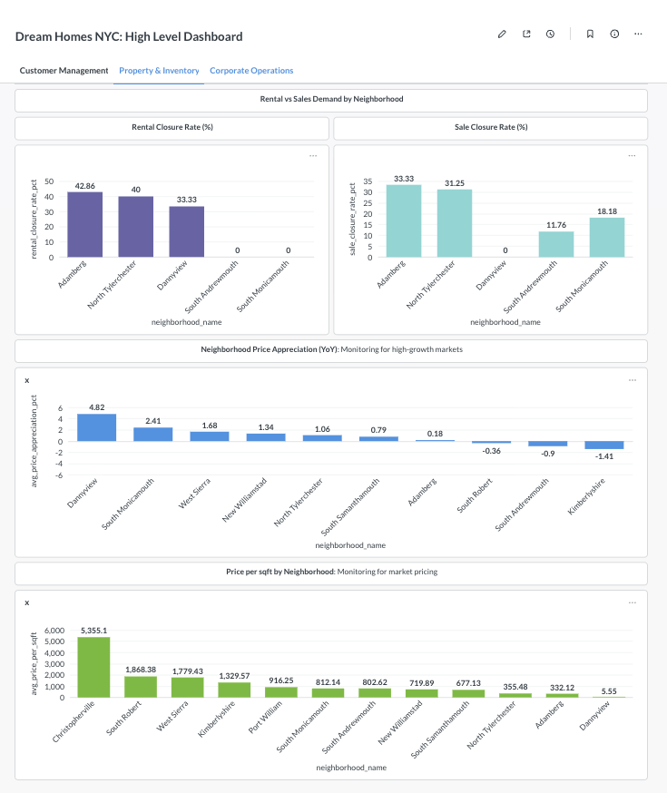
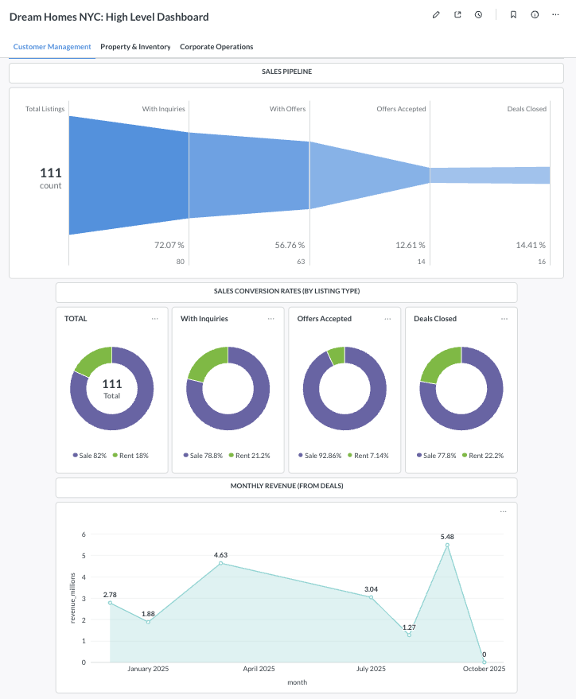
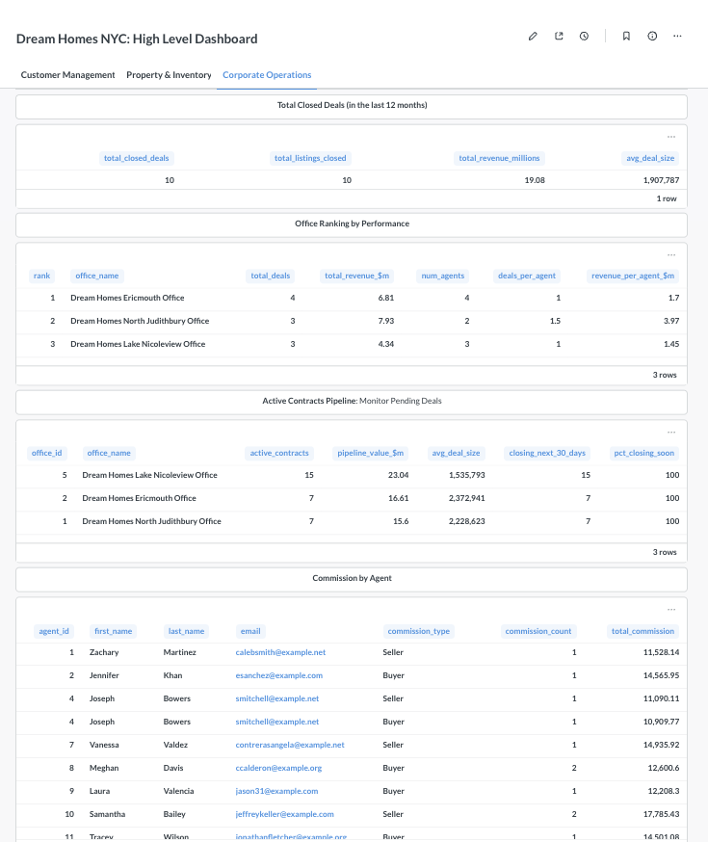

The dashboard was built using previously generated SQL queries, imported them into Metabase as questions, and selected appropriate visualizations based on the respective query or analytical purpose (e.g., bar chart, pie chart, funnel, or table). The visualizations were then arranged in a cohesive dashboard layout that is segmented based on three of our core business areas: Customer Management, Property & Inventory, and Corporate Operations.

Conclusion

This project set out to modernize Dream Homes NYC’s data infrastructure and support data-driven decision-making. We achieved this by designing a normalized PostgreSQL relational database that unifies customers, inventory, and corporate operations, and by building an ETL pipeline in Python, Faker, pandas, and SQLAlchemy to generate, clean, and load synthetic but realistic data. This replaces fragmented spreadsheets with a consistent RDBMS that enforces data integrity and supports repeatable analytics.

On top of this foundation, we developed eighteen analytical procedures directly tied to the business requirements, revealing patterns in conversion speed, neighborhood pricing, walkability, price reductions before closing, and agent and office performance. These insights are delivered through Metabase dashboards for executives and direct SQL/Python access for analysts, to make sure that both technical and non-technical users can work from the same trusted data. Combined with our recommendations for redundancy, performance tuning, and cloud hosting, the system demonstrates how Dream Homes NYC could turn its operational data into actionable intelligence once connected to real-world sources.

